STEM 4033 Final Project (100pts)
Developing an Elementary STEM Night Design Challenge

An elementary STEM night typically involves a selection of STEM activities and challenges in which students and their families participate together. The activities are often very similar to a quick challenge that introduces students to one learning concept or big idea from the standards. STEM nights are designed to encourage student curiosity and excitement about concepts related to big ideas in STEM education and to provide a fun night in the school community.

What does a quick challenge look like at a STEM night?

A STEM Night challenge should last no longer than 10-15-from start to finish. They should also:
- Focus on one big idea;
- Use simple and common materials; and
- Require students to construct/build something using a curtailed or simplified version of the design loop.

Example:

Helium Balloon Balance Challenge

Materials: helium filled balloon, string, tape, small cup, various weights (beans/rice, beads, pennies)

Tools: scissors, hole-punch, ruler

Challenge: Design a balloon that will remain at eye level for an extended period.
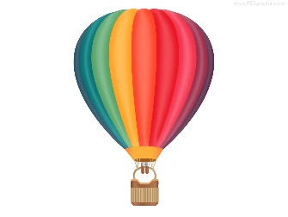
- What affects this balloon? (Balanced and Unbalanced Forces - Gravity and Lift)
- What is buoyancy? What is neutral buoyancy? (see-saw example)
- Why do the balloons rise? (Air in our atmosphere is denser than helium gas in the balloon)

Extension Challenge: Using a straw, how can you move your balanced balloon from one location to another without touching the gondola (cup). How does this work?

Assignment:
- Work individually or in a small team to develop STEM night activity that we have not done in the Introduction to STEM class.
- Initial testing of your design challenge will be during class on April 27th and the finished product will be presented to students and families at Turnbow Elementary School in Springdale on May 4, from 6:00 – 8:00pm. Please arrive at 5:30pm to set up and prepare to welcome students and families.

