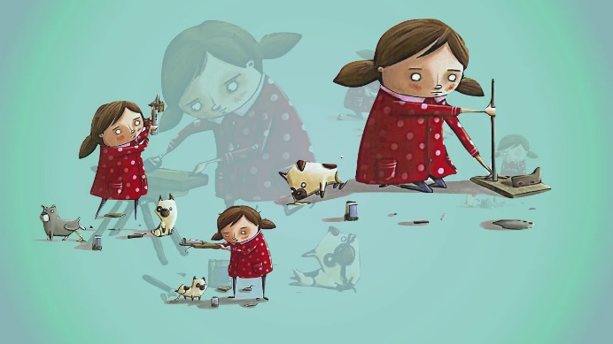
Invention Challenge - The Most Magnificent Thing
Literacy Connection: The Most Magnificent Thing by Ashley Spires
Big Ideas: Invention, Innovation, Tools, Materials, Processes, Engineering Design
Essential Question: How can you create the most magnificent thing using simple tools and materials?
Scenario: You have just learned about using simple tools and materials to create your space frame. You are also learning how the engineering design process can be used to help students solve problems and develop better solutions to challenges. How can use these new skills to develop the most magnificent thing?
Challenge: Your challenge is the create the most magnificent thing from your space frame.
Tools, Materials, and Resources:
Tools: scissors, saw/miter box, drill, sanding sponge, clamps, rulers, etc.
Materials: dimensional lumber, dowel rods, notecards, glue, springs, push pins, string, masking tape, straws, cardboard, candy sticks, sticky tack, and additional found or repurposed materials
Limitations:
- Your design must be developed using your personal design loop/process.
- Your most magnificent thing must utilize your space frame as part of the design.
- Your design will be presented and uploaded as a short YouTube video where you show your most magnificent thing and describe the process you used to create it. (Remember to NOT make the video private.)
How might this type of project fit into your future classroom?
Below are the Arkansas Engineering, Technology, and Applications of Science (ETS) Standards for Kindergarten and 6th grade. The ETS Standards are a disciplinary core idea for Arkansas K-12 science.
Kindergarten - Students who demonstrate understanding can:

K-ETS1-1 - Ask questions, make observations, and gather information about a situation people want to change to define a simple problem that can be solved through the development of a new or improved object or tool.
K-ETS1-2 - Develop a simple sketch, drawing, or physical model to illustrate how the shape of an object helps it function as needed to solve a given problem.
K-ETS1-3 - Analyze data from tests of two objects designed to solve the same problem to compare the strengths and weaknesses of how each performs.

6th Grade - Students who demonstrate understanding can:

6-ETS1-1 - Define the criteria and constraints of a design problem with sufficient precision to ensure a successful solution, taking into account relevant scientific principles and potential impacts on people and the natural environment that may limit possible solutions.
6-ETS1-2 - Evaluate competing design solutions using a systematic process to determine how well they meet the criteria and constraints of the problem.
6-ETS1-3 - Analyze data from tests to determine similarities and differences among several design solutions to identify the best characteristics of each that can be combined into a new solution to better meet the criteria for success.
6-ETS1-4 - Develop a model to generate data for iterative testing and modification of a proposed object, tool, or process such that an optimal design can be achieved.

Additionally, we will be developing curriculum projects and design standards using the Standards for Technological and Engineering Literacy (STEL). Below are just a few of the possible connections to the STEL.

Standard 1: Nature and Characteristics of Technology and Engineering
Grades 3-5
H. Design solutions by safely using tools, materials, and skills.
Grades 6-8
J. Develop innovative products and systems that solve problems and extend capabilities based on collective needs and wants
M. Apply creative problem-solving strategies to the improvement of existing devices or processes or the development of new approaches

Standard 2: Core Concepts of Technology and Engineering
Grades PreK-2
B. Safely use tools to complete tasks.
C. Explain that materials are selected for use because they possess desirable properties and characteristics.
Grades 3-5
I. Describe the properties of different materials.
K. Describe requirements of designing or making a product or system.
L. Create a new product that improves someone’s life.

Standard 7: Design in Technology and Engineering Education
Grades PreK-2
- Apply design concepts, principles, and processes through play and exploration.
- Demonstrate that designs have requirements.
- Explain that design is a response to wants and needs.
- Discuss that all designs have different characteristics that can be described.
- Illustrate that there are different solutions to a design and that none are perfect.
- Differentiate essential skills of the technology and engineering design process.
- Apply skills necessary for making in design.
Grades 3-5
- Illustrate that there are multiple approaches to design.
- Apply the technology and engineering design process.
- Evaluate designs based on criteria, constraints, and standards.
- Interpret how good design improves the human condition.
- Apply universal principles and elements of design.
- Evaluate the strengths and weaknesses of existing design solutions, including their own solutions.
- Practice successful design skills.
- Apply tools, techniques, and materials in a safe manner as part of the design process.
Grades 6-8
- Illustrate the benefits and opportunities associated with different approaches to design.
- Apply the technology and engineering design process.
- Refine design solutions to address criteria and constraints.
- Create solutions to problems by identifying and applying human factors in design.
- Assess design quality based upon established principles and elements of design.
- Evaluate the strengths and weaknesses of different design solutions.
- Improve essential skills necessary to successfully design.

