
Informal and Outdoor Education - Introduction Assignment (25 points)
Throughout the semester you may be required to share videos of your work with the instructor and the class. The most efficient way to do this is for you to create both a YouTube Channel and accompanying EDST 4113 Playlist that will be used to organize the videos that you submit for class. I will need to be able to access the link that you submit to Blackboard.

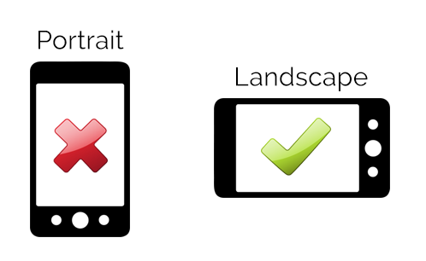
When you create a video using your phone, be sure that your phone is horizontal so that your video is recorded in landscape mode. Try to keep your videos short (1-2 minutes). You will need to save this video file to your phone or computer and then upload to the YouTube App on your phone or computer.

For this first assignment you will create a short video (1-2 minute) to introduce yourself.

Your introduction video should include the following information –

Name

Hometown – Where are you from or where do you call home?

Tell us about yourself – special skills, hobbies, fun facts, etc. - what makes you – YOU!

What are your experiences with informal and outdoor education?

What are your future related to informal or outdoor education?
- What do I need to know about you to help me be a better teacher for you this semester?

