
Creativity and Innovation - Introduction Assignment
Throughout the semester you will be required to share videos of your work with the instructor and the class. The most efficient way to do this is for you to create both a YouTube Channel and accompanying STEM 4043 Playlist (or you may also use the STEM 4033 Playlist that you previously created) that will be used to organize the videos that you submit for class.

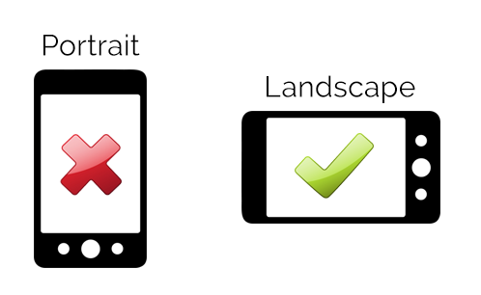
When you create a video using a digital camera or your phone, be sure that your phone is horizontal so that your video is recorded in landscape mode. Try to keep your videos short (1-2 minutes). You will need to save this video file to your computer or upload to the YouTube App on your phone.

For this first assignment you will create a short video (1-2 minute) to introduce yourself. Use a green or blue screen background to shoot your video. Then add pictures or videos related to your introduction video.

I prefer to use iMovie on my phone, primarily because it is free and easy to use – here is a 2 minute video that can help you learn this simple process - https://www.youtube.com/watch?v=RKDAba4nsh0

Your introduction video should include the following information –

Name

Hometown – Where are you from or where do you call home?

Tell us about yourself – special skills, hobbies, fun facts, etc. - what makes you – YOU!
- What do I need to know about you to help me be a better teacher for you this semester?

