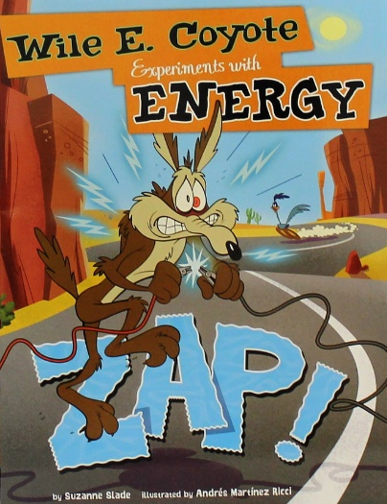
STEM CHALLENGE

Title: VibroBOT Challenge (Teacher Edition)

Grade Level: 4th

Literacy Connection: Zap! Wile E. Coyote Experiments with Energy by Suzanne Slade

Unit: Materials, Friction, Circuits, Balance, Weight, Resistance, Troubleshooting

STEM Content Standards:

Science:
Physical Science
4-PS3-1 - Use evidence to construct an explanation relating the speed of an object to the energy of that object.

4-PS3-2 - Make observations to provide evidence that energy can be transferred from place to place by sound, light, heat, and electric currents.

Technology and Engineering:
Engineering, Technology, and Applications of Science
4-ETS1-1 - Define a simple design problem reflecting a need or a want that includes specified criteria for success and constraints on materials, time, or cost.
4-ETS1-2 - Generate and compare multiple possible solutions to a problem based on how well each is likely to meet the criteria and constraints of the problem.
4-ETS1-3 - Plan and carry out fair tests in which variables are controlled and failure points are considered to identify aspects of a model or prototype that can be improved.

Standards for Technological and Engineering Literacy
Standard 2: Core Concepts of Technology and Engineering Education
- Describe how a subsystem is a system that operates as part of another, larger system.
- Illustrate how, when parts of a system are missing, it may not work as planned.
- Describe requirements of designing or making a product or system.

Standard 7: Design in Technology and Engineering Education
- Apply the technology and engineering design process.
- Evaluate designs based on criteria, constraints, and standards.
- Evaluate the strengths and weaknesses of existing design solutions, including their own solutions.
- Practice successful design skills.
- Apply tools, techniques, and materials in a safe manner as part of the design process.

Standard 10; Students will develop an understanding of the role of troubleshooting, research and development, invention and innovation, and experimentation in problem solving.
- Troubleshooting is a way of finding out why something does not work so that it can be fixed.
- Invention and innovation are creative ways to turn ideas into real things.
- The process of experimentation, which is common in science, can also be used to solve technological problems.

Mathematics:
Measurement and Data
AR.Math.Content.4.MD.A.1
- Know relative sizes of measurement units within one system of units including km, m, cm; kg, g; lb, oz.; l, ml; hr, min, sec; yd, ft, in; gal, qt, pt, c
- Within a single system of measurement, express measurements in the form of a larger unit in terms of a smaller unit. Record measurement equivalents in a two-column table

Big Ideas
- Objects in motion will stay in motion until acted upon
- Balance and placement affect objects
- Vibration can cause machines to move
- Energy and forces effect the speed and motion of an object
- Electrical circuits include conductors, insulators, switches, and outputs
- The engineering design process can help people solve common problems
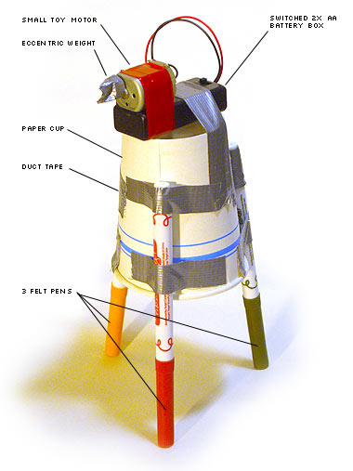
Scenario:
By placing an offset load on a rotating motor, you can cause a vibration. It occurred to you that this vibration could be used to cause motion. You decided to make a moving robot and use this as the source of motion—you are going to make a VibroBOT. A VibroBOT can be designed from simple materials and operate using a simple circuit that achieves motion created by an offset motor. You will need to apply your knowledge of electrical circuits to design and construct a simple robot. Using a simple circuit with a motor, an offset load, and a switch, design a robot that can use vibration as kinetic force. Use the principles of design thinking to plan, construct, and improve your VibroBOT to travel the great distance in a limited time.

Essential Question:
How can you design a robot that will travel the greatest distance using vibration as the force?

Challenge:
Working as a member of an engineering design team, design and construct a VibroBOT that can travel the greatest distance from a starting location during a one-minute time-period.

Limitations:
- During testing, the VibroBOT must launch from the designated starting location
- The VibroBot must be designed and constructed using the materials and tools below
- Teams must submit a STEM design journal that outlines the process used to design, construct, and test the VibroBOT
- The team should be prepared to briefly discuss the VibroBOT design prior to testing

Materials:
The materials available to construct the VibroBOT are below.
1 - Small 1.5-3V Motor | 1 - AA Battery holder with switch and wire Leads | 2 – Pencils | 1 – Large plastic cup
2 - AA Batteries | 60 cm - Duct tape | 2 – Metal paper clips | 2 – Plastic straws
2 – Wooden craft sticks | 1 – Hot glue stick | 2 - Chopsticks | 2 – Small rubber bands

Tools:
A measuring device, wire strippers, scissors, a saw, and rulers will be needed.

Results (provide these items to the teacher for assessment):
- Completed STEM design journal
- Presentation of completed VibroBOT
- Time distance for the VibroBOT during testing
Content Information:
Energy is the ability to do work. There are many kinds of energy like electrical, mechanical, thermal, etc. Today, we are going to examine electrical energy. Electrical energy is directed to the point where we use it through an electrical circuit. An electrical circuit is a path or line through which an electrical current or electrons flow. The circuit may be closed making it a loop. A closed circuit makes electrical current flow operate. It may also be an open circuit where the electron flow is cut because there is no place for the electrons to flow. An open circuit does not allow electrical current to flow. We use switches to open and close circuits.
A simple electrical circuit consists of three parts: A conductor, a source or cell, and an electrical load (a motor, a bulb, etc.). The cell or source provides power or electricity, conductors carry the electricity or power to the load, and the load uses the electricity or power. Electricity flows in a continuous loop from source (cell) to load and then back to the cell.
You can think of the electric circuit like a path made of wires (conductors) that electrons can follow. A battery or other power source provides the electricity (force) that makes the electrons move. When the electrons get to a device like a light bulb, a motor, your computer, or a refrigerator, they give it the power to make it work. The word “circuit” sounds like “circle,” and a circuit needs to be circular to work. The wires have to go from the power source (battery) to the motor (or other device) and then back again, so that the electrons can go around and around. Many circuits have a switch so that they can be switched on and off. When the switch is off, it makes a break in the circuit and the electrons are not able to flow around. When the switch is closed (turned on), it closes the break in the conductor and the electricity is able to move and make the device operate.
It is very important to know the basic parts of a simple circuit. A simple circuit has conductors, insulators, a switch, a load and a power source (battery). Here are the purposes of each part:
- Conductors: These are usually copper or aluminum wires. These wires provide a path for electrons to move (electrical flow). One end of the wire conductor connects to the power source (the cell) and the other connects to the load. The load is the item using the power (a light bulb, a motor, a buzzer, etc.) The other conductor connects the load back to the power source.
- Insulator: Conductors are usually covered with material that is not electrically conductive like plastic. Insulators prevent the electrons or electricity from escaping.
- Switch: The switch is a small break in the conductor that can be opened and closed to open or close the circuit. When the switch is closed, the circuit is closed and electricity flows. When the switch is open, the circuit is turned off and the electricity does not flow.
- The Load: The load is a small motor, light bulb or buzzer that operates when the circuit is closed (turned on).
- Cell: The power source is a cell. When two or more cells are connected, it is called a battery or a dry cell.

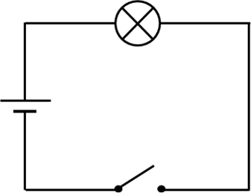
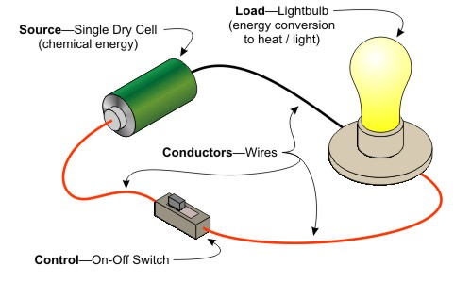

Suggestions for the Teacher:
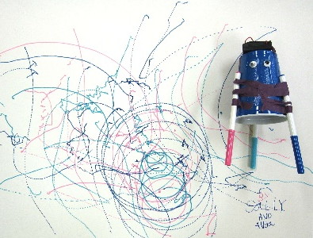
This STEM design challenge will help students understand how humans construct items to make life easier. The challenge will also help students understand simple electrical energy systems and electrical circuits. After reading the book, Zap! Wile E. Coyote Experiments with Energy by Suzanne Slade (or a similar book), and informing the students of the problem that they will be asked to solve, ask the students “What is the problem? What are you trying to construct? The content information listed above will provide you with some basic content that can be taught before and during the lesson. The students will be working in engineering design teams of two or three (as you assign them) to construct the VibroBOT. You will provide each team with the materials listed above, or additional materials that you determine. Conduct a class discussion on ideas. Ask the engineering design teams use the STEM design journal (in the Student Edition) below to create ideas for solving the problem. Tell teams to use a variety of resources to gather ideas. Tell each team to choose what they think is the best solution for the problem. Ask teams to draw a sketch of their solution in the STEM design journal before starting to construct the VibroBOT. Ask teams to think about these questions:
- What materials will you need to build or create your VibroBOT?
- How will you cause the VibroBOT to move without falling over?
- How will you balance the VibroBOT?
- What problems or difficulties might you have?
Additionally, this challenge could be easily adapted to an ArtBOT challenge

Testing:
The team with the VibroBOT that can travel the greatest distance from a specified starting location during a one-minute time period will be determined the winner. After each team has completed their design, ask them to prepare a short presentation of their VibroBOT. During this presentation, they will describe how the robot will move and how vibrations will cause movement. After the presentations are complete, place all VibroBOTs inside a 1 meter square (marked with masking tape) on a hard floor surface and ask the teams to switch on their VibroBOTs. Allow the VibroBOTs to operate for one-minute and then ask all teams to switch off their VibroBOTs and leave them where they are. Using a measuring device, record the distances each VibrBOT moved—measuring from the center of the 1 meter square. After all measurements are complete, ask the teams to complete their STEM design journals and submit the VibroBOTs and the journal for assessment.

Note: Teams could be awarded extra points for decorating their VibroBOT. Teams could use colored markers for robot legs and could be awarded points for artwork designed on paper or poster board during robot testing (see illustration at left).

Teacher Evaluation: VibroBOT
A teacher assessment rubric is provided below. You could also provide students with scores for their completed VibroBOT, the distance it traveled during the one-minute test, their completed STEM design journals, and
their design presentations.
VibroBOT Rubric
Name: Engineering Design Team Member Names:

VibroBOT was submitted along with completed STEM journal | /10
VibroBOT demonstrated creative, thoughtful, and intentional use of materials to carry out design | /20
Team clearly and effectively presented their VibroBOT to others in the class | /20
VibroBOT moved adequately during testing and used an appropriate electrical circuit | /20
VibroBOT was easy to operate and appeared neatly designed | /10
It was evident that the team followed the design process to create their VibroBOT | /20
Total | /100
Additional Comments:

STEM CHALLENGE

Title: VibroBOT Challenge (Student Edition)

Grade Level: 4th

Literacy Connection: Zap! Wile E. Coyote Experiments with Energy by Suzanne Slade

Unit: Materials, Friction, Circuits, Balance, Weight, Resistance, Troubleshooting

Big Ideas
- Objects in motion will stay in motion until acted upon
- Balance and placement affect objects
- Vibration can cause machines to move
- Energy and forces effect the speed and motion of an object
- Electrical circuits include conductors, insulators, switches, and outputs
- The engineering design process can help people solve common problems
Scenario:
By placing an offset load on a rotating motor, you can cause a vibration. It occurred to you that this vibration could be used to cause motion. You decided to make a moving robot and use this as the source of motion—you are going to make a VibroBOT. A VibroBOT can be designed from simple materials and operate using a simple circuit that achieves motion created by an offset motor. You will need to apply your knowledge of electrical circuits to design and construct a simple robot. Using a simple circuit with a motor, an offset load, and a switch, design a robot that can use vibration as kinetic force. Use the principles of design thinking to plan, construct, and improve your VibroBOT to travel the great distance in a limited time.

Essential Question:
How can you design a robot that will travel the greatest distance using vibration as the force?

Challenge:
Working as a member of an engineering design team, design and construct a VibroBOT that can travel the greatest distance from a starting location during a one-minute time-period.

Limitations:
- During testing, the VibroBOT must launch from the designated starting location
- The VibroBot must be designed and constructed using the materials and tools below
- Teams must submit a STEM design journal that outlines the process used to design, construct, and test the VibroBOT
- The team should be prepared to briefly discuss the VibroBOT design prior to testing

Materials:
The materials available to construct the VibroBOT are below.
1 - Small 1.5-3V Motor | 1 - AA Battery holder with switch and wire Leads | 2 – Pencils | 1 – Large plastic cup
2 - AA Batteries | 60 cm - Duct tape | 2 – Metal paper clips | 2 – Plastic straws
2 – Wooden craft sticks | 1 – Hot glue stick | 2 - Chopsticks | 2 – Small rubber bands

Tools:
A measuring device, wire strippers, scissors, a wood saw, and rulers will be needed.

Results (provide these items to the teacher for assessment):
- Completed STEM design journal
- Presentation of completed VibroBOT
- Time distance for the VibroBOT during testing
Testing:
The team with the VibroBOT that can travel the greatest distance from a specified starting location during a one-minute time period will be determined the winner.

Note: Teams could be awarded extra points for decorating their VibroBOT. Teams could use colored markers for robot legs and could be awarded points for artwork designed on paper or poster board during robot testing (see illustration at left).

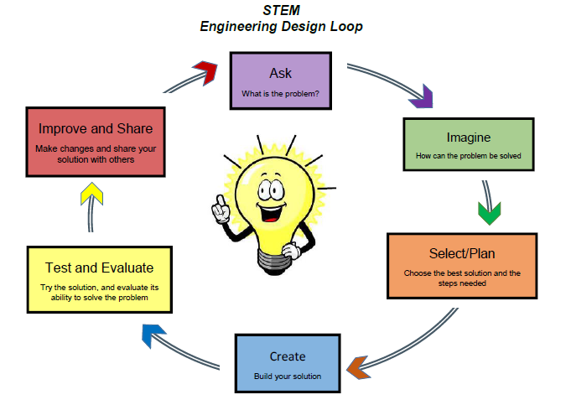
STEM DESIGN JOURNAL
Name:

Engineering Design Team Member Names:

ASK - What problem are you solving?

IMPROVE & SHARE: Can you improve your VibroBOT?

Present your VibroBOT to others?
CREATE your VibroBOT.
TEST your VibroBOT. Did it move a distance?

How far did it move in one-minute?
SELECT the best VibroBOT and draw it here
IMAGINE how you can solve this problem—Draw two or three sketches of a VibroBOT
REFLECTION: Answer the following questions.

What is electricity?

Name five things powered by electricity in your classroom

Why is electricity important?

How would life be different without electricity?

What are the parts of an electric circuit?

What is the purpose of each circuit part?

What is the difference between a closed and open electric circuit?

If you could start over, how would you change your design?

