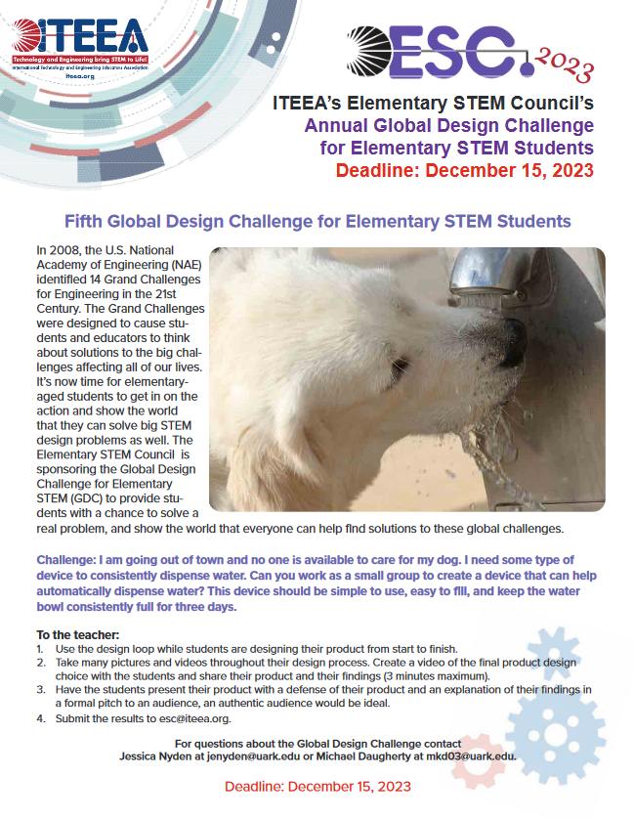

Video Submissions for ITEEA’s Elementary Global Design Challenge

Contact: Teacher - Lance Lacey llacey@ccpsweb.org (540) 937-7361 Emerald Hill Elementary School, Culpeper, VA

Team Lilly_5th_EHE
https://www.canva.com/design/DAF3FLoXf0c/UiNdhClhlQ9CnGxwGhkNOQ/watch?utm_content
=DAF3FLoXf0c&utm_campaign=designshare&utm_medium=link&utm_source=editor

Team Oliver_5th_EHE
https://www.canva.com/design/DAF3FfEZnNY/QUcnQszb8qjuq6nyqaHuyw/watch?utm_content
=DAF3FfEZnNY&utm_campaign=designshare&utm_medium=link&utm_source=editor

Team Gwenny_4th_EHE https://www.canva.com/design/DAF3FV32Nv4/h6LeywarSTFRzMDVqGVusQ/watch?utm_conte nt=DAF3FV32Nv4&utm_campaign=designshare&utm_medium=link&utm_source=editor

Team Isabelle_4th_EHE
https://www.canva.com/design/DAF3Fb-kfKA/vgVBKt85YeBIOLH15rbo8A/watch?utm_content= DAF3Fb-kfKA&utm_campaign=designshare&utm_medium=link&utm_source=editor

Team Reagan_4th_EHE https://www.canva.com/design/DAF3FUYmZws/bGQG2piod86vIpOyCQD2tw/watch?utm_conte nt=DAF3FUYmZws&utm_campaign=designshare&utm_medium=link&utm_source=editor

Team Jesse_4th_EHE https://www.canva.com/design/DAF3FZQXAUg/VwI5_CPQUDjAGzBACwlkbg/watch?utm_conte nt=DAF3FZQXAUg&utm_campaign=designshare&utm_medium=link&utm_source=editor

