Making a Simple LED Circuit
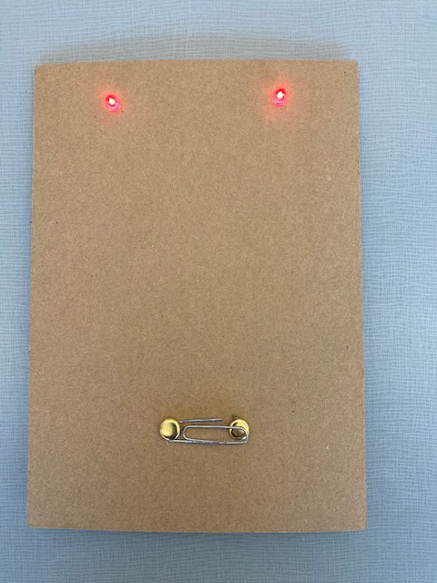
Goal: To illuminate two light-emitting diodes using LEDs, conductive wires, a coin battery, and a switch made from paper fasteners(brads) and a paper clip. To complete this task, follow these step-by-step technical/procedural directions:
Materials:
2 LEDs
Insulated wires
Black wires
2 - 7” black wires (strip the insulator from one end of the wire ½” and the opposite side of the wire ¾” – 1”)
1 - 3” black wire (strip the insulator from each end of the wire ½”)
Red wires
2 - 5” red wires (strip the insulator from each end of the wire ½”)
A coin battery (e.g., a 3V coin cell battery, like a CR2032)
A switch (2 paper fasteners or brads, and a paper clip)
2 – cardboard sheets
Masking tape
Tools:
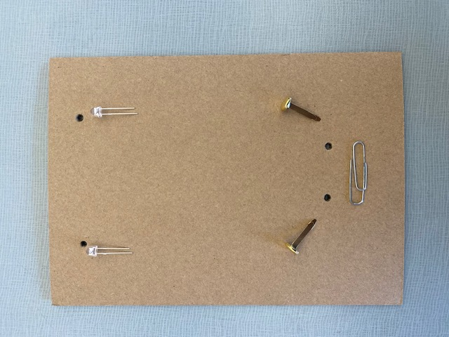
Wire stripper
+
+
-
-
Pencil
Ruler
Soldering iron and solder
Step 1:
Prepare your base by laying each of the basic components out as seen here.
Using a sharpened pencil, punch 2 holes at the top (3/4” down and 2-1/2” apart) from your cardboard base for the LEDs.
Using a sharpened pencil, punch 2 holes from the bottom (1-1/2” from the bottom) and no further apart than the length of your paper clip.

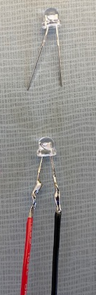
Step 2: Preparing the LEDs
LEDs have two legs, a longer positive (anode) leg and a shorter negative (cathode) leg.
Using your red wire, twist one end to the positive (longer) leg of the red LED and secure it in place (e.g., with tape or a twist-on connector). For this example, we will solder our wires to the LEDs.
Using your black wire, twist one end to the negative (shorter) leg of the other LED and secure it in place with solder.
Step 3: Building the Switch
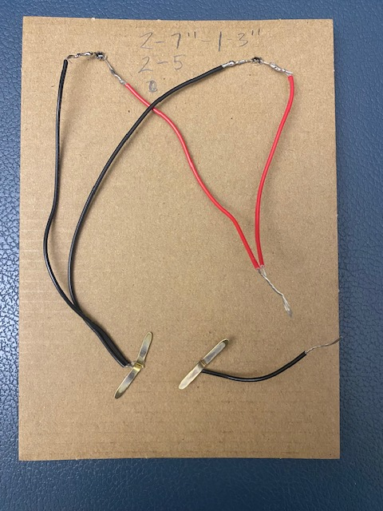
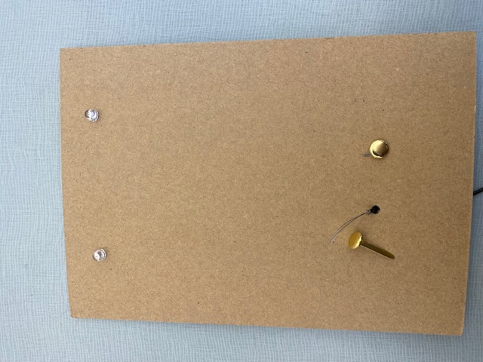
Push the black wires to the front of the cardboard base as seen to the right.
Push the two paper fasteners (or brads) through the two holes in the cardboard below the LEDs.

Wrap each end of the black wires around the one of the paper fasteners (or brads)
Attach the shorter black wire to the opposite, unconnected fastener.
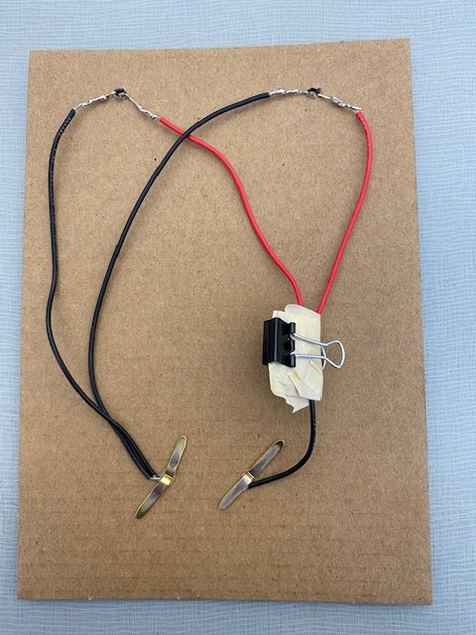
Step 6: Connecting the LEDs and Switch to the BatteryConnect the ends of the red wires to the positive terminal (anode) of the coin battery and secure with a piece of tape.
Connect the free end of the black wire to the negative terminal (cathode) of the coin battery and secure with a piece of tape.
Additionally, you can use a small binder clip to ensure that your wires have a secure connection to the battery. The tape will serve as an insulator.

Step 7: Complete the Switch
Attach one end of each small paper clip piece to one of the fasteners. These paper clips will act as the switch's "arms” when it connects with the opposite fastener.
Step 8: Testing the Circuit
To test your circuit, gently press down on the paper clip arms. This should close the switch, allowing current to flow from the battery to the LEDs, illuminating them.
Step 9: Troubleshooting
If the LEDs don't light up, make sure the connections are secure and check the polarity. LEDs are directional, so the longer leg should be connected to the positive side.
Ensure that the switch is working properly, and there are no shorts in the circuit.
Step 10: Finalize the Setup
Once you have confirmed that your LEDs light up when the switch is closed, you have successfully created your LED circuit. Release the paper clip to turn off the LEDs.
Finally, tape a back onto your cardboard to protect your finished LED circuit.
