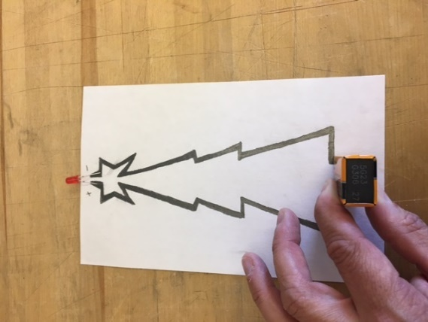
Drawing a Circuit
This quick challenge explores how a pencil can conduct electricity to create a simple electrical circuit, demonstrating the transfer of energy. Graphite in the pencil acts as a conductor—a material that allows the flow of electrical current (the movement of charged particles called electrons)—while the paper serves as an insulator—a material that resists the flow of electricity, keeping the current contained to the drawn paths.
Materials
- Soft graphite pencil (6B or softer is best for better conductivity)
- Sheet of paper or note card
- LED (Light Emitting Diode—a small light that illuminates when current flows through it in the correct direction)
- 9-volt battery (provides electromotive force or e.m.f., measured in volts, which pushes electrons through the circuit)
- Clear tape (optional, to secure components)
Safety Notes
- Never connect the LED directly to the 9-volt battery without the graphite path, as this creates a short circuit—an unintended low-resistance path that can overheat components or damage the LED. A short circuit differs from an open circuit, where the path is broken and no current flows.
- Adult supervision is recommended, especially for younger students.
- Avoid touching the battery terminals together directly.
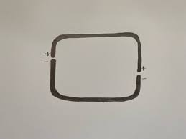
Step-by-Step Directions
- Plan your design: On the paper, sketch a simple shape or design (like a heart, star, etc.) that will form the circuit path. Ensure the design has two gaps: one for the battery terminals and one for the LED legs. The entire design should connect as a single loop when components are added, creating a closed circuit where electrons can flow continuously from the battery's anode (positive terminal) to the cathode (negative terminal) and back.
- Draw the circuit path: Using the graphite pencil, press hard and shade thick, bold lines over your sketch (about 3mm wide). Fill in solidly without leaving white spaces, as graphite's delocalized electrons allow it to conduct, but thin or long lines increase resistance (opposition to current flow), making the LED dimmer. Keep lines short (under 10-15 cm total) for best results. Mark one end of each gap with "+" (positive) and "-" (negative) to match the battery and LED polarity.
- Prepare the LED: Bend the LED's legs outward at a 90-degree angle using fingers or pliers. The longer leg is the positive (connects to the battery's positive side), and the shorter is negative. This ensures current flows in one direction, as LEDs are diodes.
- Attach the LED: Place the LED across one gap, aligning the positive leg with the "+" mark and negative with "-". Press the legs firmly onto the graphite or secure with tape. The LED should stand upright if desired.
- Connect the battery: Place the 9-volt battery across the other gap, ensuring the positive terminal touches the "+" graphite line and negative touches "-". This creates a potential difference (voltage drop) that drives electrons through the circuit, lighting the LED.
- Test and troubleshoot: If the LED lights up, you've completed a closed circuit! If not, check connections, thicken graphite lines, shorten the path, or flip polarities. Experiment with shapes—what happens in a longer circuit (higher resistance) versus a shorter one?
Essential Electricity Vocabulary
Electrical Circuit - A complete pathway for electrons to flow, transferring energy from a source like a battery to a load or components like an LED or motor.
Conductor - Material (graphite, wire, conductive tape) that allows easy flow of electrical current due to movable electrons.
Insulator - Material (paper, class, non-conductive tape, etc.) that resists electrical flow, preventing short circuits.
Electrons - Negatively charged particles that move to create current.
Anode/Cathode - Positive/negative terminals of the battery; electrons flow from cathode to anode externally.
Electromotive Force (e.m.f.) / Volts - The "push" from the battery that drives electrons, measured in volts.
Closed Circuit - Complete pathway/loop where current flows and the device (LED) works.
Open Circuit - Broken path where no current flows.
Short Circuit - Direct low-resistance path bypassing components, potentially dangerous.
Resistance - Opposition to current flow; higher in longer or thinner graphite paths.
LED - Light Emitting Diode; lights up when current passes in the correct direction.

